1. **Prompt for amount, interest rate and no. of years and calculate simple interest.**

<html>

<head>

<script src ="simple_interest.js"></script>

<title>

Simple Interest

</title>

</head>

<body>

To calculate Simple Interest Click here:<br/>

<button type = "submit" onclick="calc_interest()" >Simple Interest</button>

<br/>

Simple Interest: <div id = "b"></div>

</body>

</html>

function calc_interest()

{

var amount = prompt("Enter the Amount");

var interest = prompt("Enter the interest rate");

var years = prompt("Enter No. of Years");

var s_interest = (amount * interest *years)/100;

document.getElementById("b").innerHTML = s_interest;

}

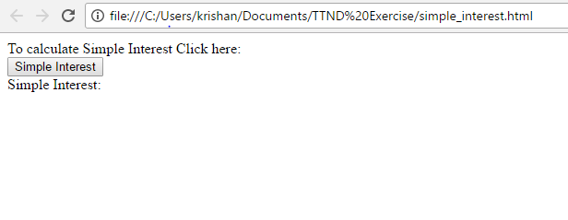

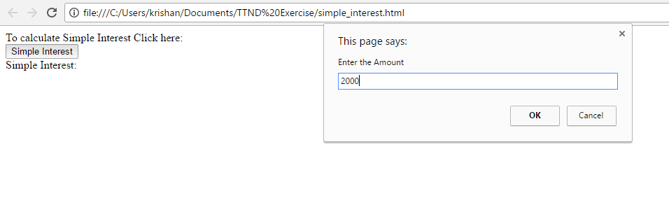

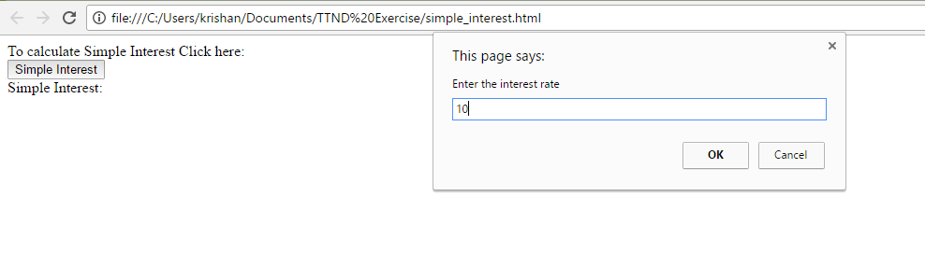

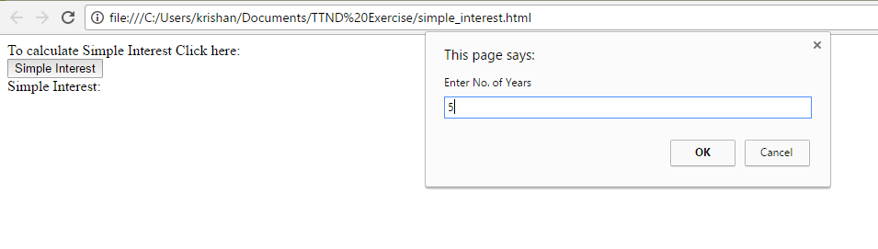

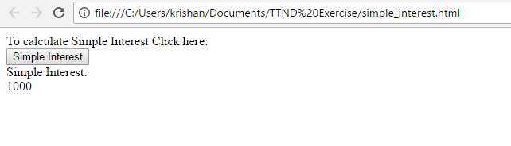

1. **Is palindrome string**

<html>

<head>

<!--Externalizing Java script-->

<script src ="exercise2.js"></script>

<title>

Exercise 2

</title>

</head>

<body>

<form onsubmit="checkPalindrom()">

Enter string:<br/>

<input type="text" id ="string" value="" name="palindrom">

<br/><br/>

<button type= "submit" >Submit</button>

</form>

</body>

</html>

function checkPalindrom()

{

var reverse="";

var x = document.getElementById("string").value;

for( var i = x.length; i >= 0; i-- )

{

var reverse = reverse + x.charAt(i);

}

if(x == reverse)

{

alert('The String is palindrome.');

}

else{

alert('The String is not palindrome!');

}

}

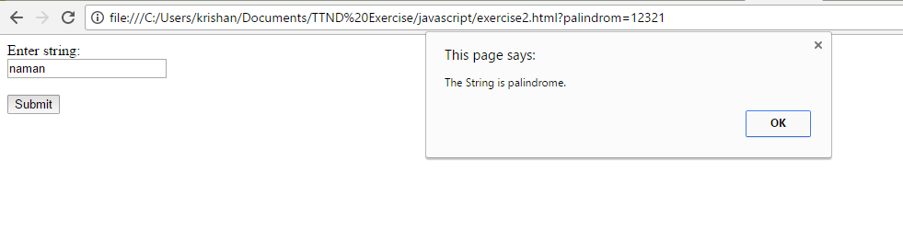

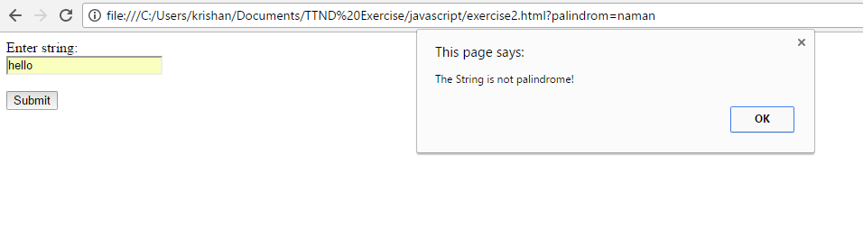

**3. Area of circle**

<html>

<head>

<script src ="exercise3.js"></script>

<title>

Exercise 3

</title>

</head>

<body>

<form onsubmit="calc_area()">

Enter radius of circle:<br/>

<input type="text" id ="radius" value="">

<br/><br/>

<button type= "submit" >Submit</button>

</form>

</body>

</html>

function calc_area()

{

var r = document.getElementById("radius").value;

r = parseInt(r);

var area = 3.14 * r * r;

alert("Area is: "+ area);

}

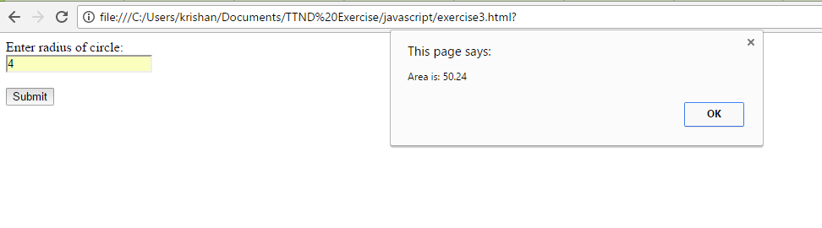

1. **On click of a button ask for the name of user and display it inside the text box**

<html>

<head>

<script src ="exercise4.js"></script>

<title>

Exercise 4

</title>

</head>

<body>

To Enter User Name Click here:<br/>

<button type = "submit" onclick="getName()">Enter Name</button>

<br/><br/>

User Name: <input type="text" id ="username" value="">

</body>

</html>

function getName()

{

var uname = prompt("Enter User Name:");

document.getElementById("username").value = uname;

}

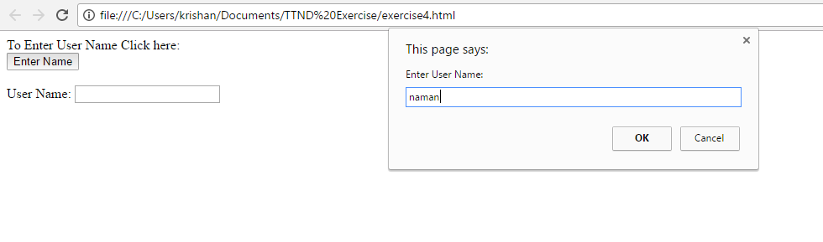

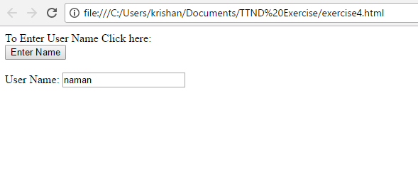

1. Copy text of one text field to another on change of text in first text box

<html>

<head>

<script src ="exercise5.js"></script>

<title>

Exercise 5

</title>

</head>

<body>

Text Field:<br/>

<input type="text" id ="text1" value="" onkeydown="copy()">

<br/><br/>

Copied text field:<br/>

<input type="text" id ="text2" value="">

</body>

</html>

function copy()

{

var a = document.getElementById("text1").value;

document.getElementById("text2").value = a;

return;

}

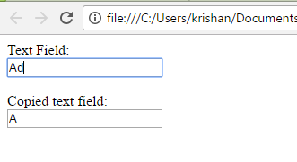

1. Allow submission of form only if the user has entered his name(not empty) and age is greater than or equals to 18

<html>

<head>

<script src="exercise6.js"> </script>

<link rel="stylesheet" href="..\html_css\style1.css">

<title>

webForm

</title>

</head>

<body>

<div id = "space"> </div>

<div id = heading> TO THE NEW

<span id="right_header">

<span id=home> Home </span>

<span id=help>Quick Help</span>

</span>

</div>

<hr/>

<form id = "form_field" onsubmit="verify()">

<div id = "form_container">

<div class = "form_header">

<spam id = "bug"> Bug Report </spam>

</div>

<div id ="form_input">

Name:*<br/>

<input type="text" id="uname"><br/><br/>

Age:*<br/>

<input type="text" id ="uage"><br/><br/>

<button type = "submit" > Send</button>

</div>

</form>

<div id = "space"> </div>

</body>

</html>

function verify()

{

var uname = document.getElementById("uname").value;

var uage = document.getElementById("uage").value;

var age = parseInt(uage);

if(uname.length < 1 )

{

alert("User Name is Empty!! ");

return;

}

else if(age < 18)

{

alert("Age is less than 18!!");

return;

}

}

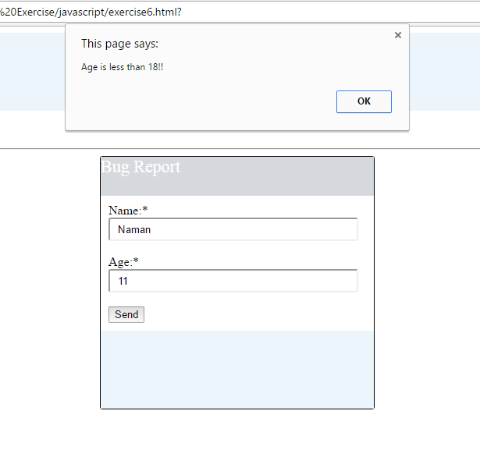

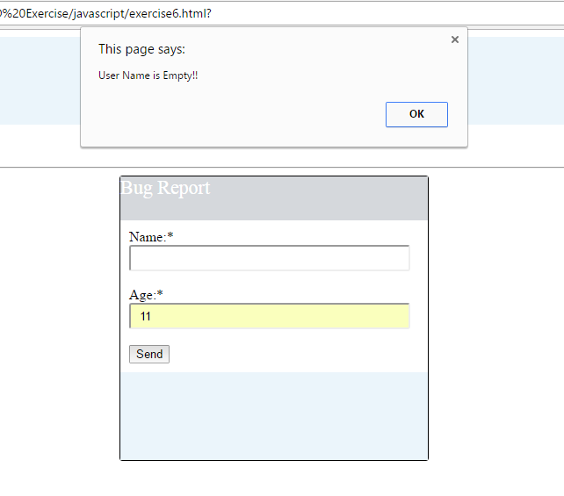

1. Change color of the div when mouse is moved over it and restore the color when mouse moves out of it

<html>

<head>

<script src ="exercise7.js"></script>

<title>

Exercise 7

</title>

</head>

<body>

<div id ="area" onmouseover="change_color(this)" onmouseout="reset_color(this)">This is a div element. </div>

</form>

</body>

</html>

function change_color(ele)

{

ele.style.background = "green";

}

function reset_color(ele)

{

ele.style.background = "yellow";

}

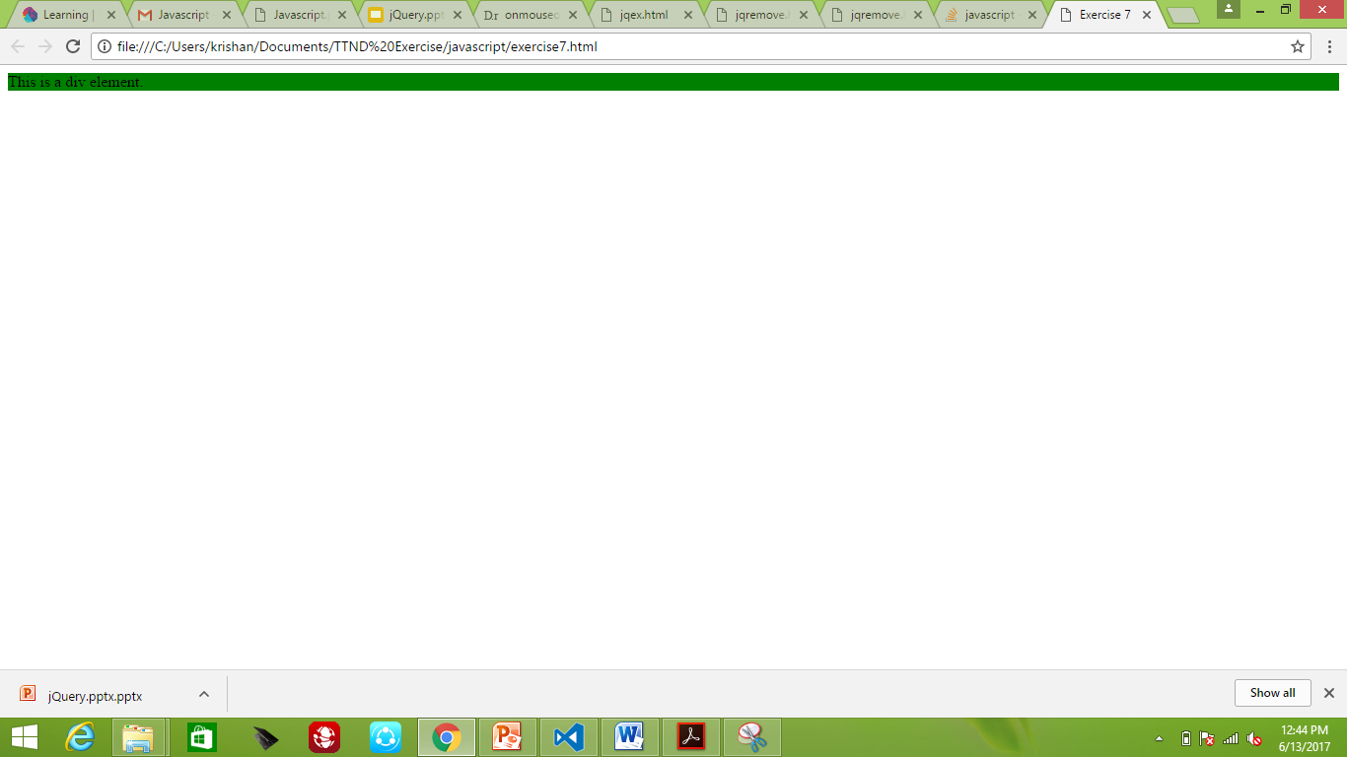

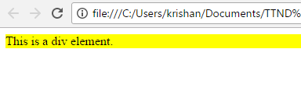

1. Externalize JavaScript file

<html>

<head>

<!--Externalizing Java script-->

<script src ="exercise3.js"></script>

<title>

Exercise 3

</title>

</head>

<body>

<form onsubmit="calc_area()">

Enter radius of circle:<br/>

<input type="text" id ="radius" value="">

<br/><br/>

<button type= "submit" >Submit</button>

</form>

</body>

</html>

function calc_area()

{

var r = document.getElementById("radius").value;

r = parseInt(r);

var area = 3.14 * r * r;

alert("Area is: "+ area);

}